**ASSIGNMENT A: SOLVING SYSTEMS OF LINEAR ALGEBRAIC EQUATIONS**

**Author: Minh Hieu Do (ID: 288414)**

**Course: Numerical Methods (ENUME)**

**Advisor: Andrzej Miekina, Ph.D., Assistant Professor**

**Warsaw, 17/04/2018**

Contents

1. The concise description of numerical algorithms 3

a. Formulation and numerical conditioning of the problem 3

b. Cholesky-Banachiewicz factorization 3

c. Computing determinants 4

d. General properties of iterative methods for solving $A∙x=b$ 4

2. The methodology for testing numerical algorithms 6

3. The results of testing numerical algorithms 7

a. Problem 1 7

b. Problem 2 7

c. Problem 3, 4 8

d. Problem 5 9

4. Conclusion 12

List of references 13

MATLAB Code 14

Figure 1. The dependence of the determinant of A(a) on a 8

Figure 2. The dependence of the condition number of A(a) on a 9

Figure 3. The dependence of $δ_{2}$ on a (N = 3) 10

Figure 4. The dependence of $δ_{∞}$ on a (N = 3) 10

Figure 5. The dependence of $δ_{2}$ on a (N = 10) 11

Figure 6. The dependence of $δ_{∞}$ on a (N = 10) 11

Figure 7. The dependence of $δ_{2}$ on a (N = 20) 12

Figure 8. The dependence of $δ_{∞}$ on a (N = 20) 12

# The concise description of numerical algorithms

## Formulation and numerical conditioning of the problem

The system of linear algebraic equations to be solved has the form:

$A∙x=b$

where:

$A=\left[\begin{matrix}\begin{matrix}a_{1,1} & a_{1,2} \\ a_{2,1} & a_{2,2}\end{matrix} & \begin{matrix}⋯ & a_{1,N} \\ ⋯ & a_{1,N}\end{matrix} \\ \begin{matrix}⋮ & ⋮ \\ a_{N,1} & a_{N,2}\end{matrix} & \begin{matrix}⋱ & ⋮ \\ ⋯ & a_{N,N}\end{matrix}\end{matrix}\right]$, $\det\left(A\right)≠0, and b=\left[\begin{matrix}b_{1} \\ b_{2} \\ \begin{matrix}⋮ \\ b_{N}\end{matrix}\end{matrix}\right], with a_{n,m}, b_{n}∈R$

The propagation of errors in the data $b$:

$$A\left(x+∆x\right)=b+∆b ⟹∆x=A^{-1}∙∆b$$

$$\left\|∆x\right\|≤\left\|A^{-1}\right\|∙\left\|∆b\right\| and \left\|∆b\right\|≤\left\|A\right\|∙\left\|x\right\|$$

$$\left\|∆x\right\|≤\left\|A^{-1}\right\|∙\left\|∆b\right\| and\frac{1}{\left\|∆x\right\|}≤\left\|A\right\|∙\frac{1}{\left\|∆b\right\|}$$

$$\frac{\left\|∆x\right\|}{\left\|x\right\|}≤\left\|A^{-1}\right\|∙\left\|A\right\|∙\frac{\left\|∆b\right\|}{\left\|b\right\|}=cond(A)∙\frac{\left\|∆b\right\|}{\left\|b\right\|}$$

where: $cond(A)$ is a condition number of the matrix $A$ defined as follows:

$$cond\left(A\right)={cond}_{p}\left(A\right)={\left\|A\right\|}_{p}{\left\|A^{-1}\right\|}_{p} for p=1, 2, …, ∞$$

The propagation of errors in the data $b$ and $A$:

$$\frac{\left\|∆x\right\|}{\left\|x\right\|}≤\frac{cond\left(A\right)∙\frac{\left\|∆A\right\|}{\left\|A\right\|}}{1-cond\left(A\right)∙\frac{\left\|∆A\right\|}{\left\|A\right\|}}+cond(A)∙\frac{\left\|∆b\right\|}{\left\|b\right\|}$$

## Cholesky-Banachiewicz factorization

A symmetric matrix $A$ is positive definite if $∀x≠0: x^{T}∙A∙x>0$

Any positive definitive matrix $A$ may be factorized in the following way:

$$A=L∙L^{T}$$

where $L=\left[\begin{matrix}\begin{matrix}l_{1,1} & l_{1,2} \\ l_{2,1} & l_{2,2}\end{matrix} & \begin{matrix}⋯ & l_{1,N} \\ ⋯ & l_{1,N}\end{matrix} \\ \begin{matrix}⋮ & ⋮ \\ l_{N,1} & l_{N,2}\end{matrix} & \begin{matrix}⋱ & ⋮ \\ ⋯ & l_{N,N}\end{matrix}\end{matrix}\right]$ is a unique matrix with positive diagonal elements

The elements of the matrix $L$ may be found by comparison of the LHS and RHS of:

$$\left[\begin{matrix}\begin{matrix}a_{1,1} & a_{1,2} \\ a_{2,1} & a_{2,2}\end{matrix} & \begin{matrix}⋯ & a_{1,N} \\ ⋯ & a_{1,N}\end{matrix} \\ \begin{matrix}⋮ & ⋮ \\ a_{N,1} & a_{N,2}\end{matrix} & \begin{matrix}⋱ & ⋮ \\ ⋯ & a_{N,N}\end{matrix}\end{matrix}\right]=\left[\begin{matrix}\begin{matrix}l_{1,1} & 0 \\ l_{2,1} & l_{2,2}\end{matrix} & \begin{matrix}⋯ & 0 \\ ⋯ & 0\end{matrix} \\ \begin{matrix}⋮ & ⋮ \\ l_{N,1} & l_{N,2}\end{matrix} & \begin{matrix}⋱ & ⋮ \\ ⋯ & l_{N,N}\end{matrix}\end{matrix}\right]∙\left[\begin{matrix}\begin{matrix}l_{1,1} & l_{2,1} \\ 0 & l_{2,2}\end{matrix} & \begin{matrix}⋯ & l_{N,1} \\ ⋯ & l_{N,2}\end{matrix} \\ \begin{matrix}⋮ & ⋮ \\ 0 & 0\end{matrix} & \begin{matrix}⋮ & ⋮ \\ ⋯ & l_{N,N}\end{matrix}\end{matrix}\right]$$

i.e. by solving the following system of linear equations:

$$l_{1,1}^{2}=a_{1,1}, l_{n,1}∙l_{n,1}=a_{n,1} for n=2,…,N$$

$$l_{2,1}^{2}+ l_{2,2}^{2}=a_{2,2}, l_{n,1}∙l_{2,1}+l_{n,2}∙l_{2,2}=a_{n,2} for n=3,…,N$$

Its solution has the form:

$$l_{n,n}=\sqrt{a_{n,1}-\sum_{i=1}^{n-1}{l_{n,i}^{2}}}$$

$l_{v,n}=\frac{a_{n,1}-\sum_{i=1}^{n-1}{l_{v,i}∙l_{n,i}}}{l_{n,n}} for v=n+1,…, N$

$$for n=1,…, N$$

The number of operations:

$$L\left(+,-\right)∞O\left(\frac{1}{6}N^{3}\right), L\left(*,/\right)∞=O\left(\frac{1}{6}N^{3}\right)and L\left(√\right)=N$$

Residual correction (interative improment of the solution)

The solution ${\hat{x}}^{(1)}$, obtained by means of the LLT factorization, may be given the form:

$${\hat{x}}^{(1)}= \dot{x}+∆x$$

where $\dot{x}$ is the exact solution of $A∙x=b$.

The equation resulting from the substitution of $\dot{x}= {\hat{x}}^{(1)}-∆x$ to $A∙x=b$:

$${A∙(\hat{x}}^{(1)}-∆x)=b$$

may be given the form:

$$A∙∆x={A∙\hat{x}}^{\left(1\right)}-b$$

An estimate $∆\hat{x}$ of $∆x$ may be obtained by solving this equation, using the already obtained results of the LLT factorization of $A$. It may be then used for correction of the solution ${\hat{x}}^{(1)}$:

$${\hat{x}}^{(2)}= {\hat{x}}^{(1)}-∆x$$

## Computing determinants

To calculate the determinant det**($A$** ) with a possibly small numerical error, one should use the LLT factorization of the matrix $A$ in the following way:

$$\det\left(A\right)=\det\left(L∙L^{T}\right)={\left[\det\left(L\right)\right]}^{2}={\left(\prod_{n=1}^{N}{l_{n,n}}\right)}^{2}$$

## General properties of iterative methods for solving $A∙x=b$

A linear iterative method for solving $A∙x=b$ is defined by the formula:

$${\hat{x}}^{\left(i+1\right)}=M∙ {\hat{x}}^{\left(i\right)}+w for i=0, 1, …,$$

where ${\hat{x}}^{\left(0\right)}$ is a given initial estimate of the solution, ***M*** and ***w*** satisfy the following conditions:

$\dot{x}=M∙\dot{x}+w,$ where $\dot{x}$ is the exact solution;

$sr\left(M\right)<1$ (the convergence condition).

The speed of convergence, i.e. the speed of approaching zero by:

$$\left\|{∆\hat{x}}^{\left(i\right)}\right\|= \left\|{\hat{x}}^{\left(i\right)}-\dot{x}\right\| for i=0, 1, …,$$

increases if $sr\left(M\right)$ goes down.

Typical stop conditions:

$$\frac{\left\|{\hat{x}}^{\left(i+1\right)}-{\hat{x}}^{\left(i\right)}\right\|}{\left\|{\hat{x}}^{\left(i\right)}\right\|}<δx and \frac{\left\|{A∙\hat{x}}^{\left(i+1\right)}-b\right\|}{\left\|b\right\|}<δb$$

where $δb$ is an indicator of admissible (relative) error.

$$δ_{2}=\frac{{\left\|{\hat{x}}_{N}-{\dot{x}}_{N}\right\|}_{2}}{{\left\|{\dot{x}}_{N}\right\|}_{2}} and δ_{∞}=\frac{{\left\|{\hat{x}}_{N}-{\dot{x}}_{N}\right\|}_{∞}}{{\left\|{\dot{x}}_{N}\right\|}_{∞}}$$

# The methodology for testing numerical algorithms

* Creating the matrix
$$A\left(a\right)=\left[\begin{matrix}\begin{matrix}f^{2}\left(a\right) & -2f\left(a\right) & 2f\left(a\right) \\ -2f\left(a\right) & 8 & -8 \\ 2f\left(a\right) & -8 & 12\end{matrix} & ⋯ & \begin{matrix}2f\left(a\right) & -2f\left(a\right) \\ -8 & 8 \\ 12 & -12\end{matrix} \\ ⋮ & ⋱ & ⋮ \\ -\begin{matrix}2f\left(a\right) & 8 & -12\end{matrix} & ⋯ & \begin{matrix}4\left(N-1\right) & -4\left(N-1\right) \\ -4\left(N-1\right) & 4N\end{matrix}\end{matrix}\right]$$

$$with f\left(a\right)=\frac{2}{a}-2$$

* Determine the smallest value $a_{N}$ of the parameter $a$, satisfying the equation $\det\left(A_{N}\left(a\right)\right)=0$
* Repeat calculations for N = 3, 10, 20.
* Make the graphs of the dependence of the determinant of $A_{N}\left(a\right)$ and of the condition number of $A_{N}\left(a\right)$ on $a$ for $a∈[a_{N}-0.01, a_{N}-0.01]$
* Divide the range of a by 101, we have 102 values of a.
* Design a MATLAB procedure for solving systems of linear algebraic equations using the Cholesky-Banachiewicz method, denoted here with the acronym CB. Check its correctness via solving, by means of this procedure, several systems of linear algebraic equations whose solutions are known.
* Apply the CB procedure for solving the following systems of linear algebraic equations:

$A_{N}\left(a\right)∙x=b_{N}\left(a\right)$ with $b_{N}\left(a\right)=A_{N}\left(a\right)∙{\dot{x}}_{N}$ and ${\dot{x}}_{N}={\left[1, 2, …, N\right]}^{T}$

for N = 3, 10, 20 and selected vales of $a∈[a_{N}-0.01, a_{N}-0.01]$

* For each solution ${\hat{x}}_{N}$ compute the values of the following accuracy indicators
$$δ_{2}=\frac{{\left\|{\hat{x}}_{N}-{\dot{x}}_{N}\right\|}_{2}}{{\left\|{\dot{x}}_{N}\right\|}_{2}} and δ_{∞}=\frac{{\left\|{\hat{x}}_{N}-{\dot{x}}_{N}\right\|}_{∞}}{{\left\|{\dot{x}}_{N}\right\|}_{∞}}$$

* Compare the values of $δ_{2}$ and $δ_{∞}$, computed for the solutions obtained by means of the procedure CB, with the corresponding values of $δ_{2}$ and $δ_{∞}$, computed for the solutions obtained by means of the operator "\" implemented in MATLAB. Illustrate the results of comparison with the adequate graphs.

# The results of testing numerical algorithms

## Problem 1

$$\det\left(A_{N}\left(a\right)\right)=0⇔f\left(a\right)=\frac{2}{a}-2⇔a=1$$

$$a_{N}=1$$

## *Problem 2*

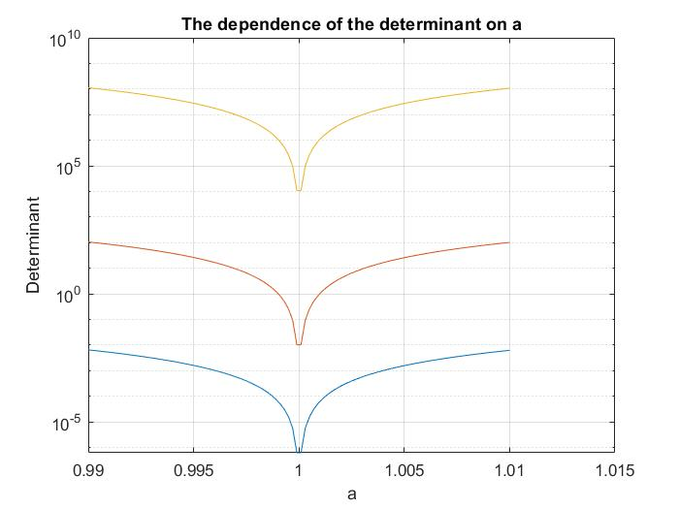

Figure 1. The dependence of the determinant of A(a) on a

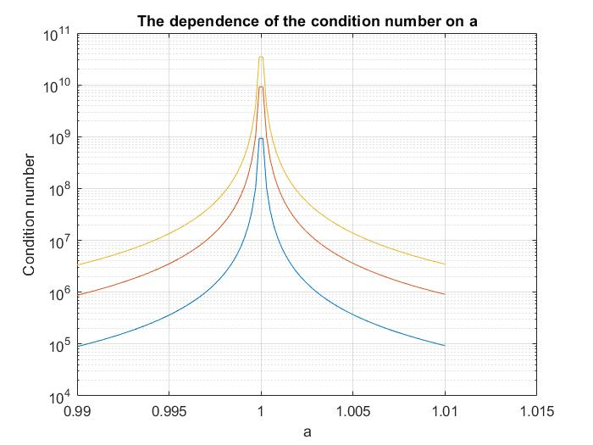

Figure 2. The dependence of the condition number of A(a) on a

Color of line:

Blue: N = 3

Red: N = 10

Orange: N = 20

## Problem 3, 4

The procedure and results are shown in program designed.

## Problem 5

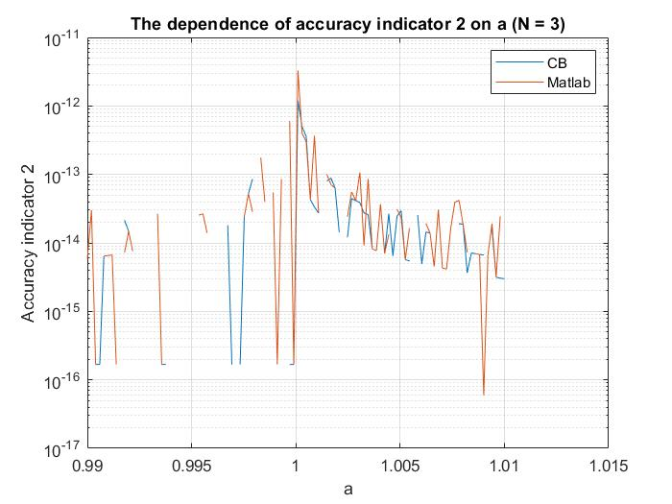

Figure 3. The dependence of $δ_{2}$ on a (N = 3)

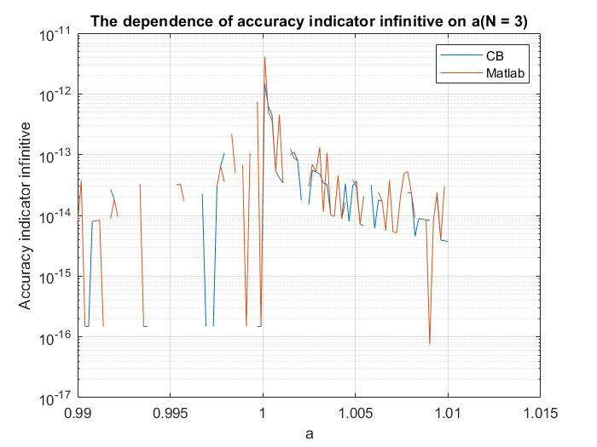

Figure 4. The dependence of $δ_{∞}$ on a (N = 3)

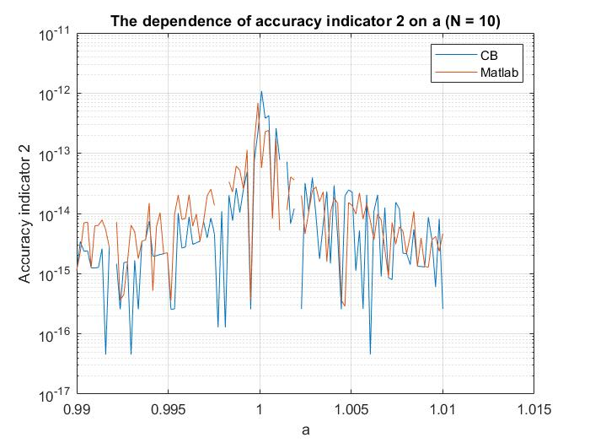

Figure 5. The dependence of $δ_{2}$ on a (N = 10)

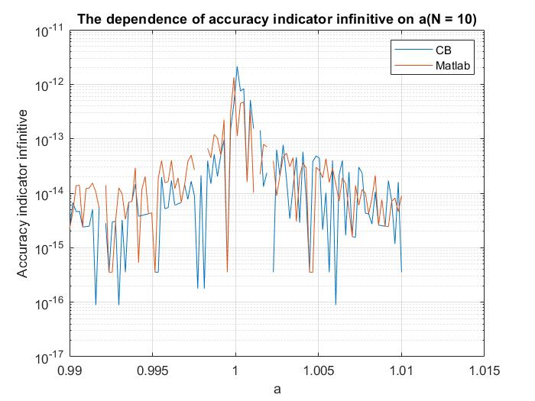

Figure 6. The dependence of $δ_{∞}$ on a (N = 10)

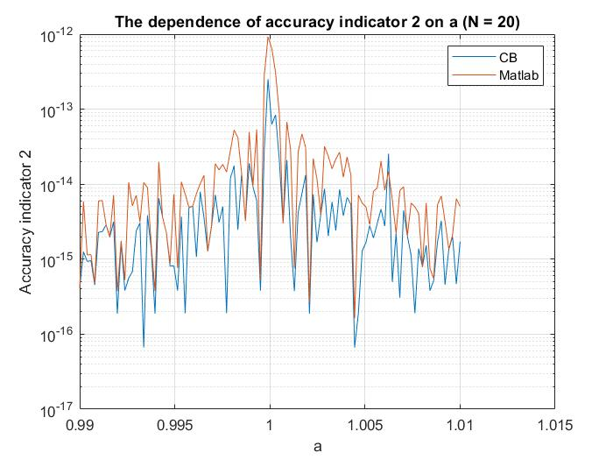

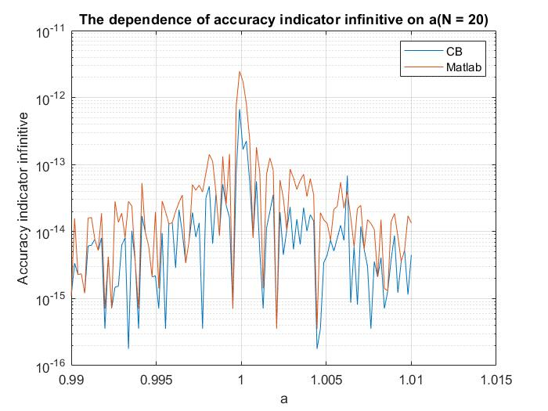Figure 7. The dependence of $δ_{2}$ on a (N = 20)

Figure 8. The dependence of $δ_{∞}$ on a (N = 20)

# Conclusion

Two numerical methods of solving linear system of equations: Cholesky-Banachiewicz and MATLAB/Simulink built-in method, were used to solve and analyze the solutions of linear algebraic equations.

Taking in account the obtained results, we can conclude that the “slash” operator method is more accurate than the CB method, no matter which accuracy indicator is used, nor the size of the matrix.

The Cholesky is almost completely deterministic, which is ensured by the uniqueness theorem for this decomposition. Another order of associative operations may lead to the accumulation of round-off errors; however, the effect of this accumulation is not so large as in the case of not using the accumulation mode when computing dot products.

# List of references

R. Z. Morawski, Lecture notes for ENUME students

A. Miękina, ENUME MatLab Intro 2018

MathWorks, MATLAB Documentation, <https://www.mathworks.com/help/index.html>

# MATLAB Code

clear all

close all

f = @(x) 2/x - 2;

Ns = [3, 10, 20];

for n = 1 : 3

N = Ns(n);

X = [1:N]';

%%Problem 1-----------------------------------------------

an = 1;

%problem 2----------------------------------------------

d = 101;

a = (an-0.01 : 0.02/d : an+0.01);

figure (1)

for i = 1 : d+1

A = createMatrix(N, a(i));

detA(i) = det(A);

condA(i) = cond(A);

B = A * X;

Xn = solveCB(A, B);

XnMatlab = A\B;

accuracy(i) = norm(Xn - X)/norm(Xn);

accuracyInf(i) = norm(Xn - X, Inf)/norm(Xn, Inf);

accuracyMatlab(i) = norm(XnMatlab - X)/norm(XnMatlab);

accuracyInfMatlab(i) = norm(XnMatlab - X, Inf)/norm(XnMatlab, Inf);

end

figure (1)

semilogy(a, detA);

title("The dependence of the determinant on a")

xlabel("a")

ylabel("Determinant")

hold on

grid on

figure (2)

semilogy(a, condA);

hold on

grid on

title('The dependence of the condition number on a')

xlabel('a')

ylabel('Condition number')

%Problem 4, 5----------------------------------------

figNum = 2*n;

figure (figNum + 1)

semilogy(a, accuracy, a, accuracyMatlab);

legend('CB', 'Matlab')

hold on

grid on

title(['The dependence of accuracy indicator 2 on a (N = ', num2str(N), ')'])

xlabel('a')

ylabel('Accuracy indicator 2')

figure (figNum + 2)

semilogy(a, accuracyInf, a, accuracyInfMatlab);

legend('CB', 'Matlab')

hold on

grid on

title(['The dependence of accuracy indicator infinitive on a(N = ', num2str(N), ')'])

xlabel('a')

ylabel('Accuracy indicator infinitive')

end

%%Function to create matrix A ----------------------------------

function A = createMatrix(N, x)

f = @(x) 2/x - 2;

for i = 1 : N

for j = 1 : N

if i == 1 && j == 1

A(i,j) = f(x).^2;

elseif i == 1 || j == 1

A(i,j) = (-1).^abs(i-j).*2.*f(x);

else

A(i,j) = (-1).^(i+j).*4.*min(i,j);

end

end

end

end

%%Cholesky function----------------------------------------------

function [L] = Cholesky(A)

N = length(A);

L = A-A;

for i = 1 : N

L(i, i) = sqrt( A(i, i) - L(i, :)*L(i, :)' );

for j = (i + 1) : N

L(j, i) = ( A(j, i) - L(i, :)*L(j, :)' )/L(i, i);

end

end

end

%%Function to sovle linear system---------------------------------------

function [X] = solveCB(A, b)

L = Cholesky(A);

Lt = L';

[n , ~] = size(A);

y = zeros(n, 1);

X = zeros(n, 1);

y(1) = b(1)/L(1, 1);

for i = 2 : n

y(i) = (b(i) - L(i, :)*y)/L(i, i);

end

X(n) = y(n)/Lt(n, n);

for i = n-1 : -1 : 1

X(i) = (y(i) - Lt(i, :)*X)/L(i, i);

end

end